**How to query POE2 API**

1. Go to the trade website<https://www.pathofexile.com/trade2/search/poe2/Standard>

2. Open developer tools in chrome (hit f12) or other browser you use, and go to the network tab

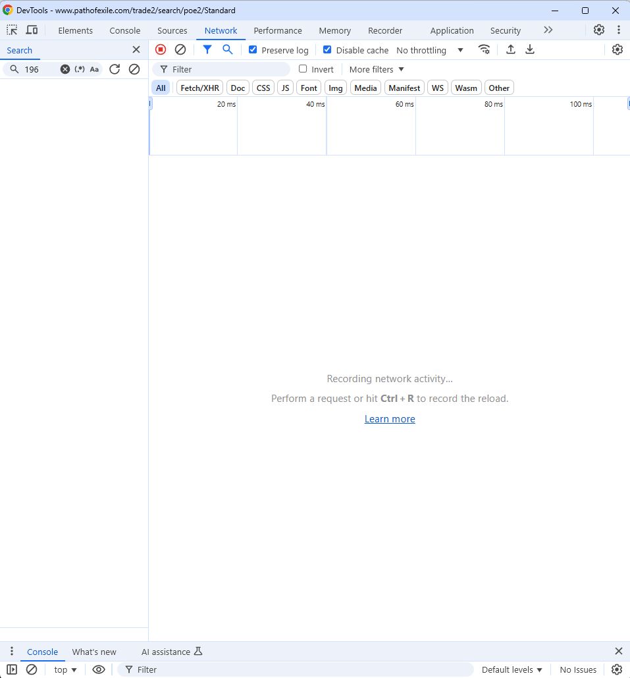

Keep the windows open side by side

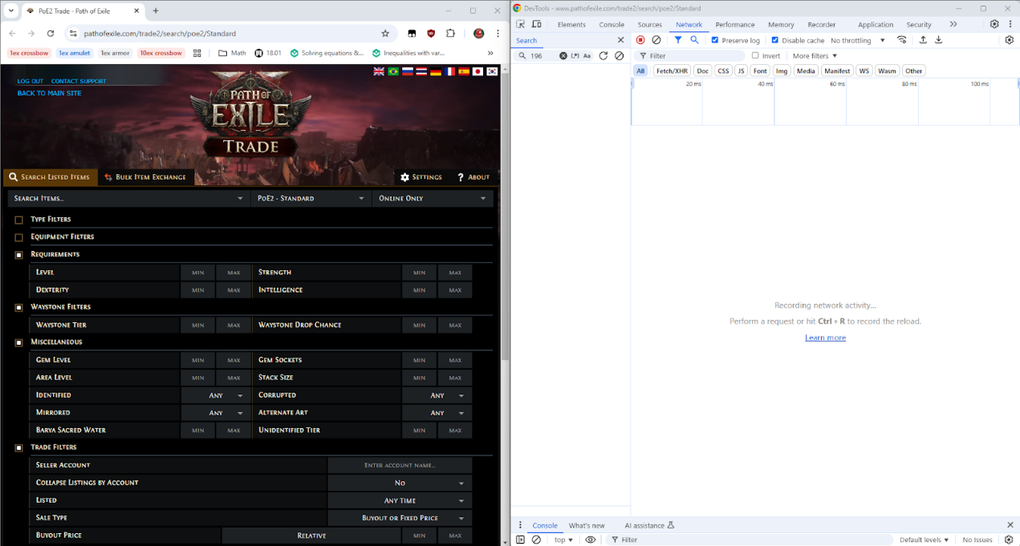

3. Pick your preferred search filters on the trade website

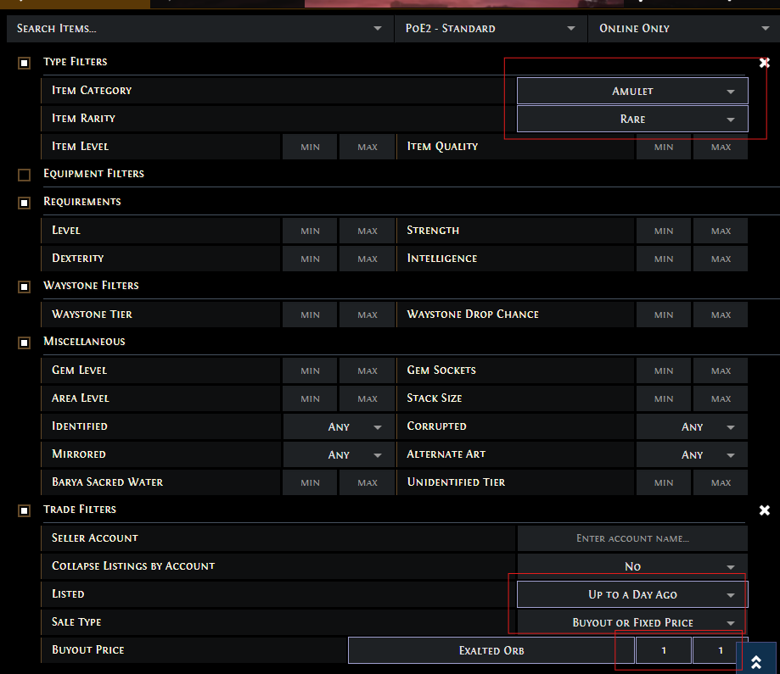

4. Go ahead and hit the search button on the website. You should see the following two API calls

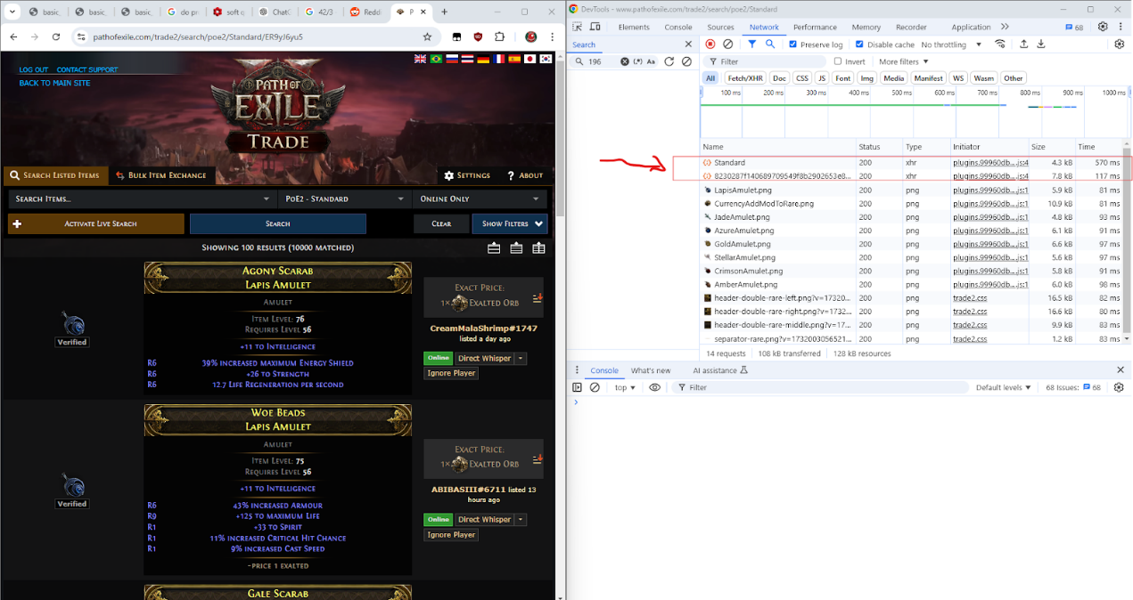

Zoomed in



These are the two API calls we're interested in. The first one is a POST request that sends our search criteria, and in return we get 100 search results in the form of listing IDs along with a query ID. The response from the first API call "Standard" looks something like:

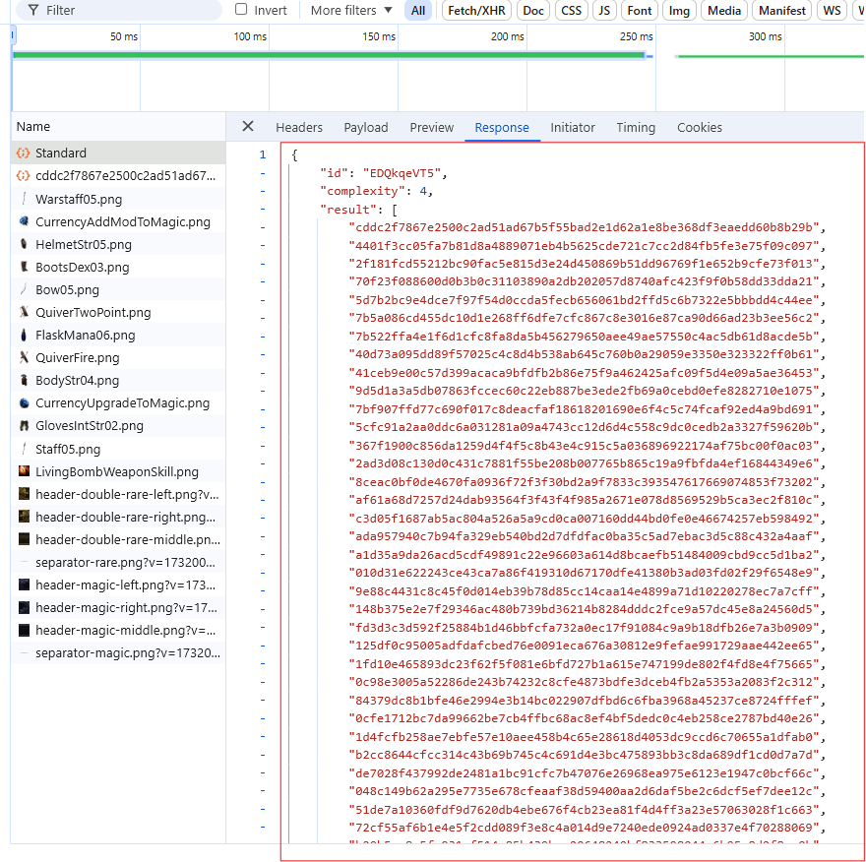

As you can see there's an "id" and a list of 100 UUIDs. In order to get the actual details for each of these 100 listings we must perform batch queries using the second API. If you inspect the second API call you will notice the following:

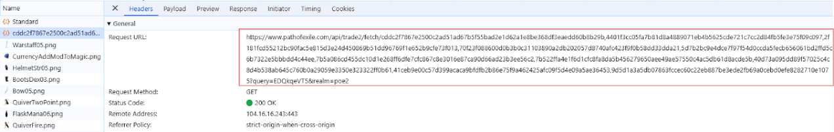

**If we zoom in the URL looks something like:**

https://www.pathofexile.com/api/trade2/fetch/cddc2f7867e2500c2ad51ad67b5f55bad2e1d62a1e8be368df3eaedd60b8b29b,4401f3cc05fa7b81d8a4889071eb4b5625cde721c7cc2d84fb5fe3e75f09c097,2f181fcd55212bc90fac5e815d3e24d450869b51dd96769f1e652b9cfe73f013,70f23f088600d0b3b0c31103890a2db202057d8740afc423f9f0b58dd33dda21,5d7b2bc9e4dce7f97f54d0ccda5fecb656061bd2ffd5c6b7322e5bbbdd4c44ee,7b5a086cd455dc10d1e268ff6dfe7cfc867c8e3016e87ca90d66ad23b3ee56c2,7b522ffa4e1f6d1cfc8fa8da5b456279650aee49ae57550c4ac5db61d8acde5b,40d73a095dd89f57025c4c8d4b538ab645c760b0a29059e3350e323322ff0b61,41ceb9e00c57d399acaca9bfdfb2b86e75f9a462425afc09f5d4e09a5ae36453,9d5d1a3a5db07863fccec60c22eb887be3ede2fb69a0cebd0efe8282710e1075?query=EDQkqeVT5&realm=poe2

If we break this URL down into its components you notice the following.

**First you have the base URL:** https://www.pathofexile.com/api/trade2/fetch/

**The base URL is followed by 10 comma delimited listing IDs from our first query:** cddc2f7867e2500c2ad51ad67b5f55bad2e1d62a1e8be368df3eaedd60b8b29b,4401f3cc05fa7b81d8a4889071eb4b5625cde721c7cc2d84fb5fe3e75f09c097,2f181fcd55212bc90fac5e815d3e24d450869b51dd96769f1e652b9cfe73f013,70f23f088600d0b3b0c31103890a2db202057d8740afc423f9f0b58dd33dda21,5d7b2bc9e4dce7f97f54d0ccda5fecb656061bd2ffd5c6b7322e5bbbdd4c44ee,7b5a086cd455dc10d1e268ff6dfe7cfc867c8e3016e87ca90d66ad23b3ee56c2,7b522ffa4e1f6d1cfc8fa8da5b456279650aee49ae57550c4ac5db61d8acde5b,40d73a095dd89f57025c4c8d4b538ab645c760b0a29059e3350e323322ff0b61,41ceb9e00c57d399acaca9bfdfb2b86e75f9a462425afc09f5d4e09a5ae36453,9d5d1a3a5db07863fccec60c22eb887be3ede2fb69a0cebd0efe8282710e1075  
**The listing IDs are followed by the query ID from our first query and a realm:** ?query=EDQkqeVT5&realm=poe

**Now if we inspect the response for this API call we see the following:**

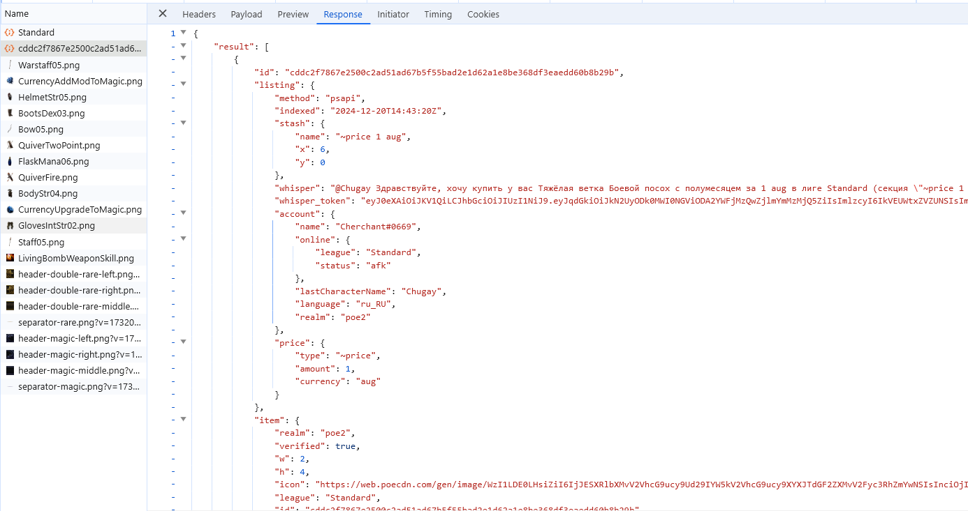

**Zoomed in**

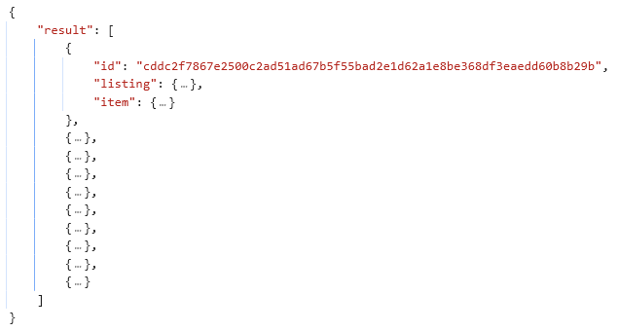

This is exactly what we were looking for, its a list of 10 search results for our query.

**Now how do we actually reproduce these API calls in code?**

Right click on the API call, go to Copy, and select your preferred query mechanism. If you want python simply choose "Copy as cURL (bash)" and translate the copied command into python by pasting it into <https://curlconverter.com/>

Copying the API calls in this way will also copy your session ID and cookies for authentication so it should just work.

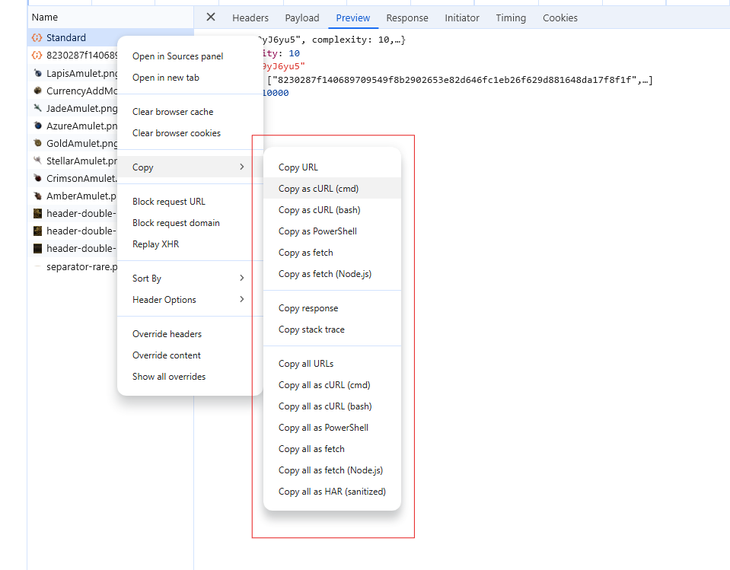

You can do the same for the 2nd query, and make a few adjustments to make it general enough to work for any query.

**Tips**

Play around with the trade website filters and see how it changes the first API call payload when you hit the search button to better understand the structure of a query filter.

Be wary of rate limits - that is if you query too quickly with a script you will be timed out for ~30-60 seconds, and then if you continue querying too quickly you might get timed out for 30 minutes.

2 seconds between any API call should be a safe starting point. Then gradually begin to reduce the number to find the sweet spot.

**Good luck and have fun!**

**The end.**